Professional Practices
Chapter 2
What is Professional Practice?
Professional practice means following the standards, ethics, and responsibilities of a specific job or profession. It ensures that work is done ethically, legally, and skillfully.
The Ethical Point of View
Most people share basic values like:
- Wanting to live
- Seeking happiness
- Achieving their goals
There are two ways to see the world:
- Selfish view – Thinking only about yourself and what you want.
- Ethical view – Respecting others and their values too.
Society is a group of people following rules.
Rules help everyone live better over time.

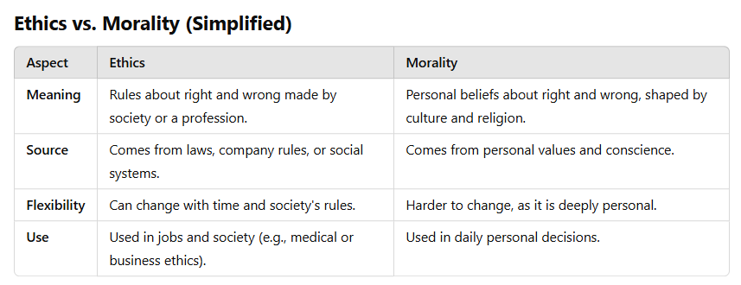
Business Ethics vs. Personal Morality
- A lawyer may ethically defend a client they believe is guilty because the legal system demands fair representation.
- However, their morality might make them feel guilty for helping someone they believe did wrong.
Medical Ethics vs. Morality
- A doctor may be ethically bound to keep patient information confidential.
- But if keeping a secret could harm others (e.g., a patient with a contagious disease refusing to inform close contacts), the doctor's morality might push them to warn others.
Key Takeaway
Ethics = external rules that guide behavior in society or professions.
Morality = internal beliefs about right and wrong.
Why Study Ethics?
Ethics: Choosing the Right Thing to Do
- New technology brings new problems.
- There may not be clear rules for new situations.
- Ethics helps decide what is right when there are no set answers.
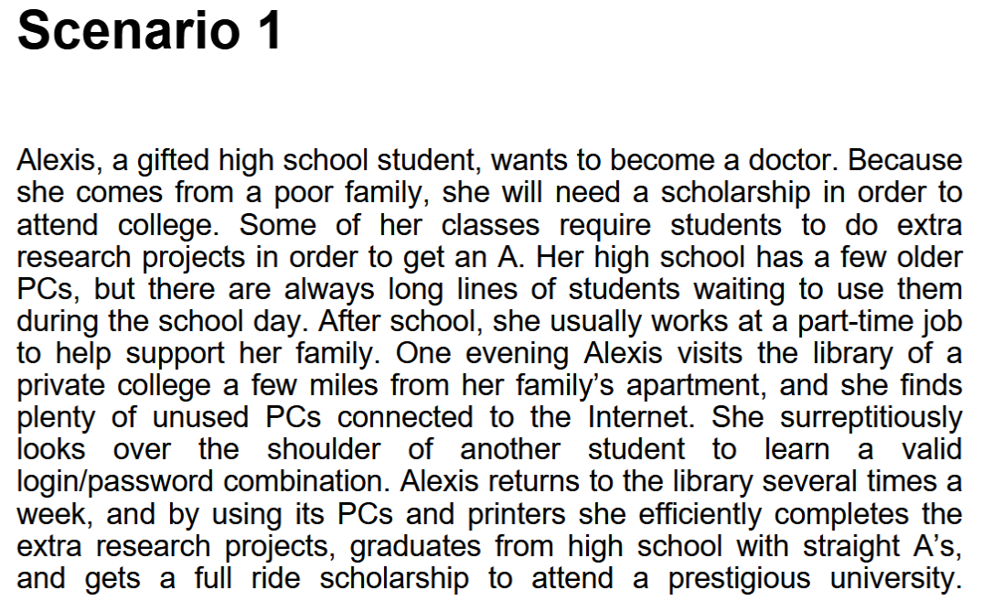
Did Alexis do anything wrong?
- Yes. According to professional ethics, her actions were unethical. She gained unauthorized access to the private college’s computer system, which is a violation of ethical and legal standards.
Who benefited from Alexis’s course of action?
- Alexis benefited the most. She was able to complete her assignments efficiently, maintain excellent grades, and secure a scholarship.
Who was hurt by Alexis’s course of action?
- The private college was harmed as their resources were used without permission. Other students who legitimately needed access to those resources may have been impacted as well.
Did Alexis have an unfair advantage over her high school classmates?
- Yes. Other students had to wait in long lines for limited school computers, while Alexis had unauthorized access to better resources, giving her an edge.
Would any of your answers change if it turns out Alexis did not win a college scholarship after all?
- No. The ethical concern remains the same regardless of the outcome. The act of gaining unauthorized access is still wrong.
Are there better ways Alexis could have achieved her objective?
- Yes. She could have spoken to her teachers about her situation, applied for grants for technology access, or used public library computers within authorized hours.
What additional information, if any, would help you answer the previous questions?
- Knowing if Alexis had any alternative options available at her school or community centers would help assess the fairness of her actions. Also, understanding the policies of the private college regarding guest computer use would clarify the extent of the violation.
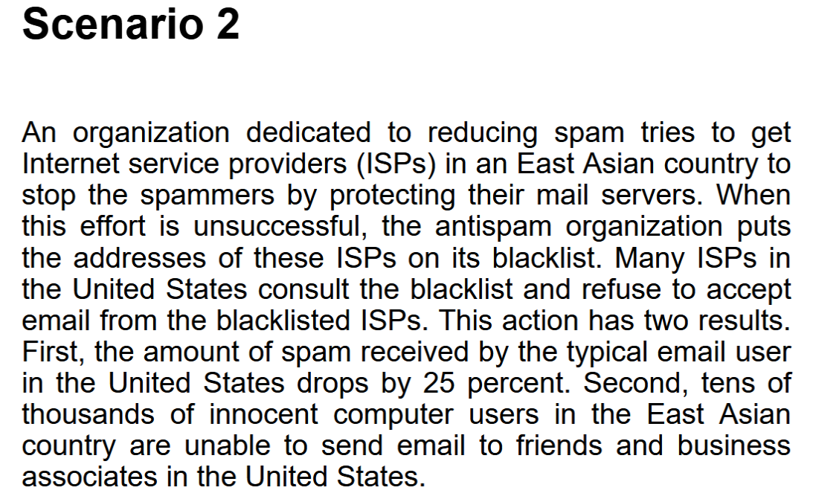
Did the antispam organization do anything wrong?
Theory of Ethical Relativism:
There are no universal moral standards that apply to everyone. What is considered "right" or "wrong" varies between individuals or societies.
Example: One person may believe that lying is always wrong, while another may think it is acceptable in certain situations—both can be "right" based on their perspectives
Two Types of Ethical Relativism:
- Subjective Relativism (Individual-Based)
- Each person determines their own moral principles.
- Example: If you believe stealing is wrong, it is wrong for you, but someone else may see it as justified in some cases.
- "What's right for you may not be right for me."
- Cultural Relativism (Society-Based)
- Morality depends on cultural norms and traditions.
- No culture’s moral code is superior to another’s.
- Example: Some cultures accept arranged marriages, while others value personal choice in marriage—both are considered "right" within their respective societies.
Case for Subjective Relativism
- People Disagree on Moral Issues
- Even well-intentioned and intelligent individuals have different views on morality.
- Example: Some believe in high taxes for wealth redistribution, while others see it as unfair.
- Ethical Debates Are Often Unresolved
- Moral discussions can be endless with no clear "right" answer.
- Example: Some people believe the death penalty is fair because it punishes serious crimes. Others think it is wrong because every life is valuable.
Both sides have strong arguments, but no universal agreement exists, so the debate goes on without a clear resolution.
Case Against Subjective Relativism
- Blurs line between doing what is right and doing what you want
- If morality is based only on personal beliefs, people could justify selfish or harmful actions just because they think it’s right.
- Example: A thief might believe stealing is fine for survival, but that doesn’t make it morally right.
- No moral distinction between good and bad actions
- Subjective relativism suggests that all moral views are equally valid, which means we cannot say one person’s actions are better than another’s.
- Example:
- Mother Teresa spent her life helping the poor and sick.
- Hitler caused suffering and death for millions.
Both believed they were doing the right thing, but can we really say their actions were equally "good"?
This is a major issue with subjective relativism—it fails to recognize real moral differences between good and evil actions.
Modified Version of SR
This modified version of subjective relativism—"I can decide what’s right for me, as long as my actions don’t hurt anybody else"—tries to address the biggest problem of the original theory: it prevents people from justifying harmful actions like Hitler’s.
How It Solves the Problem:
- Mother Teresa helped others and did not cause harm, so her actions would still be seen as morally good.
- Hitler, on the other hand, caused immense suffering and death, so his actions would not be justified under this modified version.
This approach adds a basic moral limit—avoiding harm to others—which helps separate good actions from harmful ones.
SR and Tolerance
A big problem with subjective relativism is that it clashes with the idea of tolerance. If everyone decides their own right and wrong, then even intolerant beliefs, like racism, would have to be accepted as valid. But most people agree that racism is wrong, which creates a contradiction. Also, saying “People should be tolerant” is a universal rule, but subjective relativism rejects universal rules. This makes the theory inconsistent because it cannot support tolerance while also allowing everyone to choose their own morals.
Relativism rejects universal moral norms
- Since subjective relativism denies absolute moral rules, saying that everyone should be tolerant contradicts its own principles.
Decisions may not be based on reason
- If people decide morality for themselves, they can use any method they choose, even irrational ones like rolling dice or reading tarot cards. This goes against logic and reason.

Not a workable ethical theory
Because it allows for contradictions and lacks a solid foundation for ethical decision-making, subjective relativism is not a practical approach to morality
Cultural Relativism
What is “right” and “wrong” depends upon a society’s actual moral guidelines. These guidelines vary from place to place and from time to time. A particular action may be right in one society at one time and wrong in other society or at another time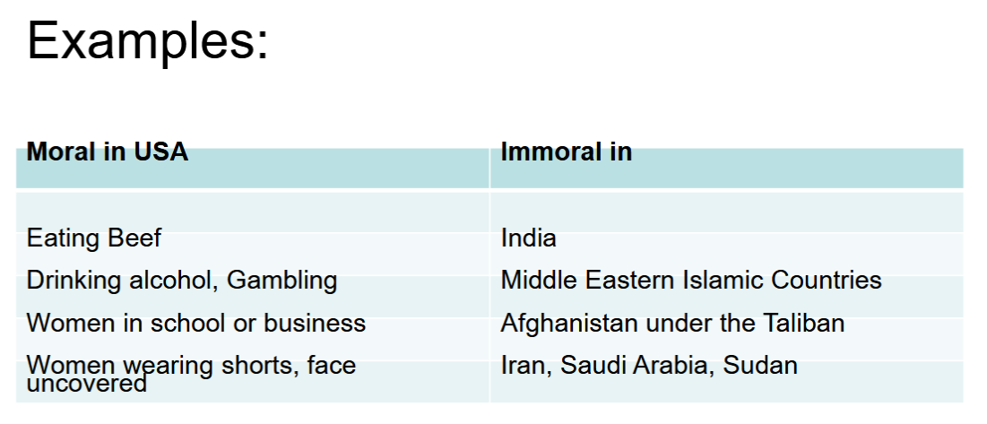
Case for Cultural Relativism
Different social contexts demand different moral guidelines
- What is considered right or wrong depends on cultural traditions and circumstances.
- Example: In some cultures, arranged marriages are the norm, while in others, personal choice in marriage is valued.
It is arrogant for one society to judge another
- No single culture has the absolute right to declare its morals superior.
- Example: In some cultures, eating certain animals (like cows in India) is seen as wrong, while in others, it is completely normal. Judging another culture’s food practices based on one’s own beliefs can be unfair.
Case Against Cultural Relativism
Different moral views don’t mean they should exist
- Just because two societies have different moral beliefs doesn’t mean both are equally valid or justified.
- Example: One culture might accept child labor, while another bans it. That doesn’t mean child labor is morally acceptable just because a society allows it.
Doesn’t explain how moral guidelines are determined
- If someone is new to a society, how do they figure out what is morally right or wrong?
- Example: A traveler moving to a new country might struggle to understand its moral customs without clear guidance.
What if there are no clear cultural norms?
- Some issues are global and don’t belong to a single culture.
- Example: The Internet allows millions to share copyrighted music. Some believe it’s fine, while others see it as stealing. Without a single cultural norm, who decides what’s right?
Doesn’t account for changing moral values
- Societies evolve, and moral values change over time.
- Example: Slavery was once accepted in many cultures but is now widely condemned. If cultural relativism were absolute, it would suggest that past norms were just as valid as today’s, which is problematic.
It cannot solve conflicts between cultures
- Cultural relativism says all cultural beliefs are valid, but what happens when two cultures strongly disagree?
- Example: Some Palestinians in Gaza believe in fighting for their land, while some Israelis believe in expanding settlements. If both sides are "right" in their own culture, there is no way to resolve the conflict.
Just because many practices are acceptable doesn’t mean all are (many/any fallacy)
- Different cultures have different customs, but that doesn’t mean every practice is good.
- Example: In computer programming, there are many good ways to write comments, but that doesn’t mean any way is correct. Similarly, not every cultural practice should automatically be considered right.
Societies share common core values
- Despite differences, all societies agree on certain basic moral rules.
- Example: Every society cares for newborn babies because they are helpless, ensuring the survival of the community. Similarly, truthfulness is valued because trust is essential for people to live together peacefully.
Only indirectly based on reason
- Traditions often start because they serve a purpose, but over time, people follow them simply because they are expected to, without questioning their logic.
- Example: A cultural practice may have begun for safety or health reasons, but later, people continue it just out of habit, without understanding why it started.
Not a workable ethical theory
Since cultural relativism relies on traditions rather than reasoning, it does not provide a strong basis for making moral decisions. If people follow customs without questioning them, harmful traditions may continue without justification.
Divine Command Theory:
- Good actions: those aligned with God’s will
- Bad actions: those contrary to God’s will
- Holy books reveal God’s will
- We should use holy books as moral decision-making guides

Case for Divine Command Theory
- We owe obedience to our Creator
- God is all-good and all-knowing
- God is the ultimate authority
Case Against Divine Command Theory
Different holy books disagree on certain teachings
- Religions have different moral guidelines, so which one should people follow?
- Example: Some religions allow eating certain foods, while others forbid them. If morality comes from divine command, these contradictions create confusion.
Society is multicultural and secular
- Not everyone follows the same religion, and many people don’t follow any religion at all.
- Example: In a diverse society, laws and morals need to apply to everyone, not just those of a specific faith.
Some modern moral problems are not directly addressed in scripture
- Many ethical issues today didn’t exist when religious texts were written.
- Example: Topics like artificial intelligence, climate change, and genetic engineering are not mentioned in ancient scriptures, making it hard to rely on them for guidance.
Based on obedience, not reason
- Morality should be based on logical reasoning, not just following rules without question.
- Example: If an action is right only because a religious text says so, people may not think critically about its impact.
Not a workable ethical theory
Since it relies on faith and varies across religions, divine command theory cannot be a universal basis for ethics in a diverse world.
Ethical Egoism
Each person should focus exclusively on his or her self-Interest. According to this theory, those actions are good that provides maximum long-term benefit.

Example:
For example, if I rely on a friend for daily rides to work and her car breaks down, she needs $100 to fix it. If I lend her the money, I temporarily lose $100, but I ensure I can still get to work and earn income. If I don't help, I might lose my job. So, lending the money is the right choice because it benefits me the most in the long run.
Case for Ethical Egoism
Ethical Egoism makes sense because:
- We naturally do what benefits us.
- It's better if everyone takes care of themselves.
- When individuals focus on their well-being, the whole community can improve.
- Many moral rules are based on self-interest anyway.
Case Against Ethical Egoism
A moral philosophy that seems easy isn’t always the best one.
- We often understand what’s good for others.
- Focusing only on self-interest can lead to unethical actions.
For example, in the 1970s, a rich doctor treated a poor woman who had minor health issues caused by malnutrition. He knew she worked hard but earned very little. After just five minutes, he charged her $25, even though she only had $12. He took all her money, leaving her unable to buy food. This shows how self-interest can lead to unfair and harmful actions. There were no negative consequences to the doctor as a result of his
action. According to the theory of ethical egoism, the doctor did the right thing he was only supposed to take his own interest into account, and receiving $12 from the woman was to his advantage. This answer, however, is incorrect; what the doctor did was morally reprehensible.
- Other moral principles are superior to principle of self-interest
- People who take the good of others into account lead happier lives
- By definition, does not respect the ethical point of view
- Not a workable ethical theory
Kantianism
Kantianism is a moral philosophy developed by Immanuel Kant that focuses on duty, moral rules, and rationality rather than self-interest or consequences.
Key Ideas:
- Moral Duty: People should act based on moral rules, not personal gain.
- Categorical Imperative: An action is right if it can be made a universal rule that everyone should follow.
- Treat People as Ends: We should respect others as individuals, not use them as tools for our own benefit.
Example:
If you find a lost wallet, Kantianism says you should return it—not because of a reward or fear of punishment, but because honesty is a universal moral duty.
Imp: Immanuel Kant: Only thing in the world that is good without qualification is a good will.
Categorical Imperative (1st formulation)
An action is right if it can be made a universal rule that everyone should follow.
Illustration of 1st Formulation
Question: Can someone in a tough situation make a promise while intending to break it later?
- Proposed Rule: “I may make promises with the intention of breaking them.”
- Intent: The person wants others to believe their promise so they can get what they need.
- Universalization: Imagine if everyone made and broke promises.
- Problem: If everyone did this, promises would become meaningless—no one would trust them.
- Contradiction: The person wants their promise to be believed, but if everyone did the same, promises would lose their value.
Conclusion: The rule is flawed, so the answer is No—breaking promises is morally wrong.
A Quick Check for Kantian Ethics
When deciding if an action is morally right, reverse roles:
- Imagine someone doing the same thing to you.
- How would you feel?
- If you’d react negatively, it’s a sign that the action violates the Categorical Imperative.
Example:
If you consider lying to someone, ask yourself:
"How would I feel if they lied to me?"
- If you wouldn’t like it, then lying is morally wrong based on Kant’s principle.
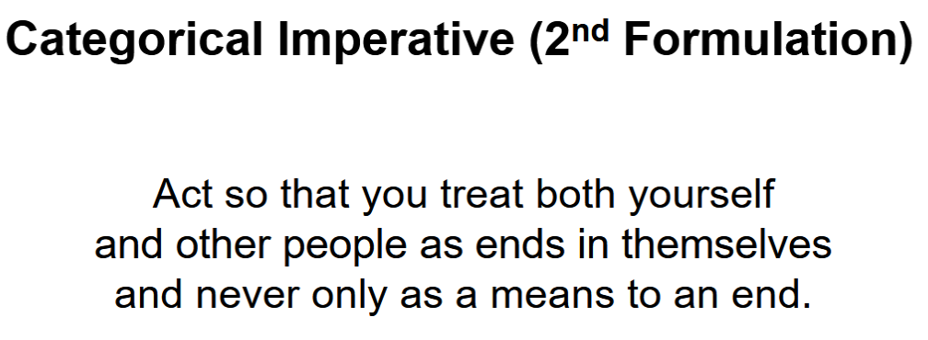
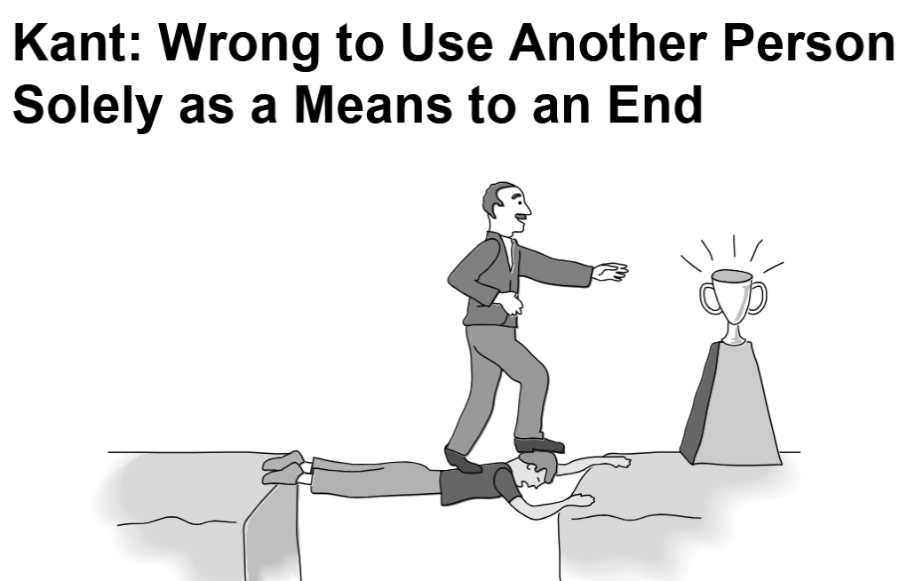
Plagiarism Scenario: Carla's Case
Background
- Carla is a single mother, working full-time while taking two evening courses per semester.
- Her history class requires a lot of work.
- She has been getting A’s on all assignments.
- Due to time constraints, she buys a final report and submits it as her own.
Kantian Evaluation (1st Formulation - Universal Law)
- Carla wants credit for a report she didn’t write.
- Proposed rule: "Anyone can submit work done by someone else."
- If universalized (applied to everyone), reports would no longer reflect students' knowledge. Professors would stop giving credit for them.
- Contradiction: The purpose of reports is to measure learning, but this rule would make them useless.
- Conclusion: Carla’s action is self-defeating and morally wrong.
Kantian Evaluation (2nd Formulation - Respect for Others)
- Carla used someone else’s work as her own.
- She deceived the professor.
- She treated the professor as a tool to pass the course.
- End goal: Passing the course.
- Unethical means: Manipulating the professor by submitting false work.
Conclusion: Carla’s action was wrong because she used dishonesty to achieve her goal.
Case for Kantianism
- It matches common moral thinking: “What if everyone did this?”
- It creates clear and universal moral rules for everyone.
- It treats all people equally and with respect.
Perfect and Imperfect Duties
Perfect duty: duty obliged to fulfill without exception
- Example: Telling the truth
Imperfect duty: duty obliged to fulfill in general but not in every instance
- Example: Helping others
Case Against Kantianism
Not all actions fit neatly into a moral rule.
Conflicts between rules can be hard to solve.
- If a perfect duty (e.g., never lie) conflicts with an imperfect duty (e.g., help others), the perfect duty wins.
- If two perfect duties conflict, there’s no clear solution.
No exceptions are allowed, even in extreme cases.

Act Utilitarianism
Act Utilitarianism is a moral theory that says an action is right if it produces the greatest happiness for the greatest number of people.
Example
Imagine you are in a burning building with two possible escape routes:
- Saving one person trapped in Room A.
- Saving three people trapped in Room B.
Principle of Utility (Utilitarianism)
Jeremy Bentham and John Stuart Mill developed the Principle of Utility, which states that an action is morally right if its benefits outweigh its harms and wrong if its harms outweigh its benefits. Utility refers to a tendency of an object to produce happiness or prevent unhappiness for an individual or a community
- In Utilitarianism, different words like happiness, advantage, benefit, good, and pleasure all refer to positive outcomes—things that make people feel better or improve their lives. Similarly, words like unhappiness, disadvantage, cost, evil, and pain all refer to negative outcomes—things that cause harm, suffering, or make life worse.
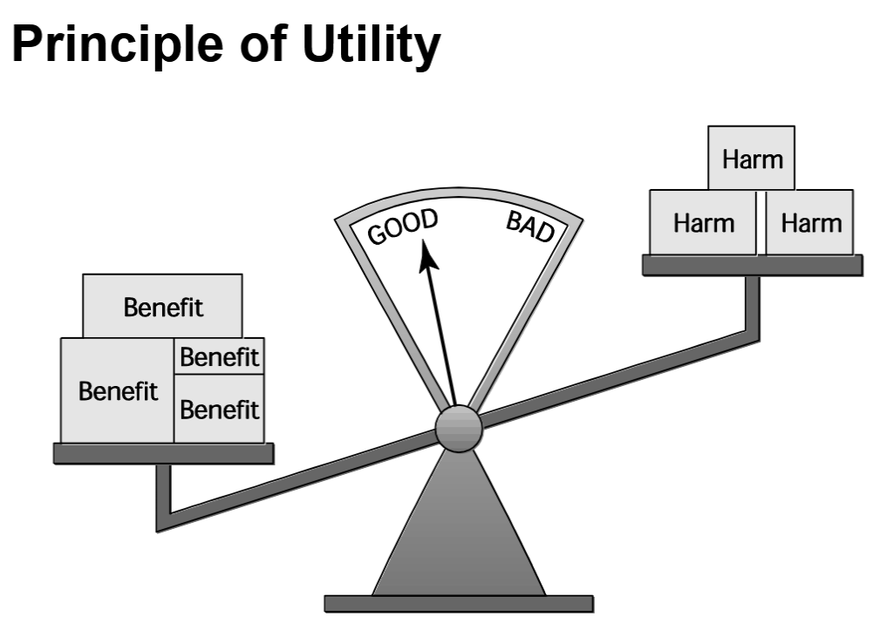
Act Utilitarianism
Utilitarianism is a moral theory that judges actions only by their consequences, not by the intent behind them. It is a consequentialist theory, meaning that an action is right if it leads to good outcomes.
- If the total happiness increases (sum > 0), the action is good.
- If the total happiness decreases (sum < 0), the action is bad.
- The best action is the one that maximizes total happiness.
Example:
A firefighter has time to save either one person or three people from a burning building.
- Saving one person = One life saved, but three lost (sum is low).
- Saving three people = Three lives saved, one lost (sum is higher).
Act Utilitarianism says: The firefighter should save the three people because it produces the greatest overall happiness.
Workable ethical theory
Rule utilitarianism
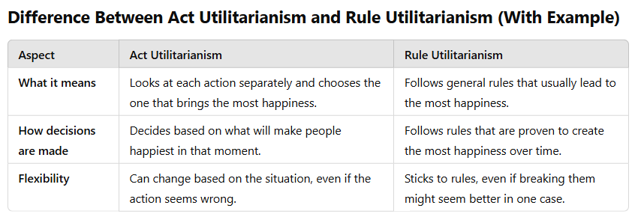
Example: Lying to a Friend
Situation: Your friend asks if their outfit looks good, but you think it doesn’t.
- Act Utilitarianism: You lie if it makes your friend feel good because that brings more happiness at the moment.
- Rule Utilitarianism: You follow the rule that honesty builds trust and leads to more happiness in the long run, so you tell the truth kindly.
Main Difference:
Act utilitarianism focuses on what makes people happy right now, while rule utilitarianism thinks about what will make people happiest in the long run

Anti-Worm Scenario:
What happened?
In August 2003, the Blaster worm infected thousands of Windows computers.
Soon after, the Nachi worm appeared and:
- Took control of infected computers.
- Deleted Blaster from the system.
- Installed a security patch to fix the problem.
- Spread itself to other vulnerable computers.
Evaluating Nachi Using Rule Utilitarianism
Proposed Rule:
"If I can create a worm that removes harmful viruses and protects computers, I should do it."
Who Benefits?
People who don’t update their computers regularly.
Who is Harmed?
- People using networks (the worm caused slowdowns).
- People whose computers were taken over without permission.
- System administrators who had to deal with its effects.
Conclusion:
More harm than good → Even though Nachi tried to help, it still invaded computers without consent, caused network problems, and created security risks. So, releasing such a worm is wrong.
Case for Rule Utilitarianism
- Not every moral decision requires performing utilitarian calculus
- Moral rules survive exceptional situations
- Avoids the problem of moral luck
- Reduces the problem of bias
- Appeals to a wide cross-section of society
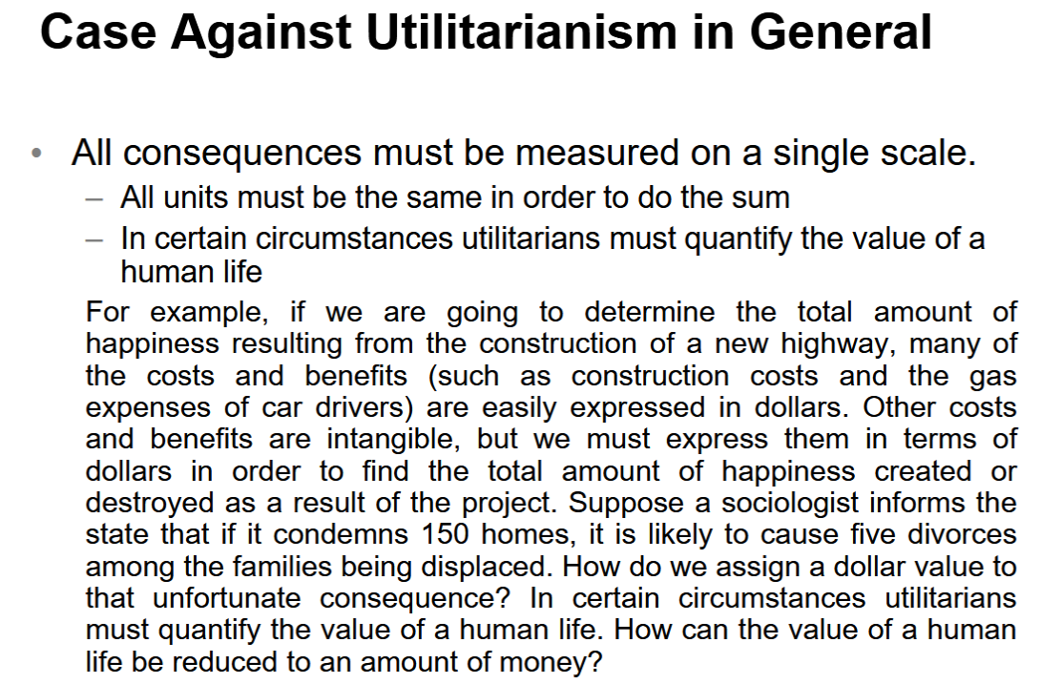

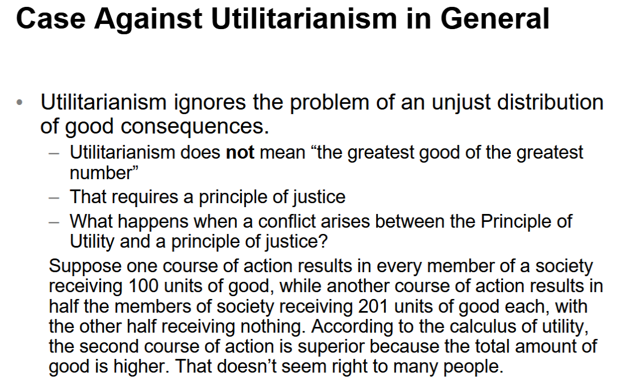
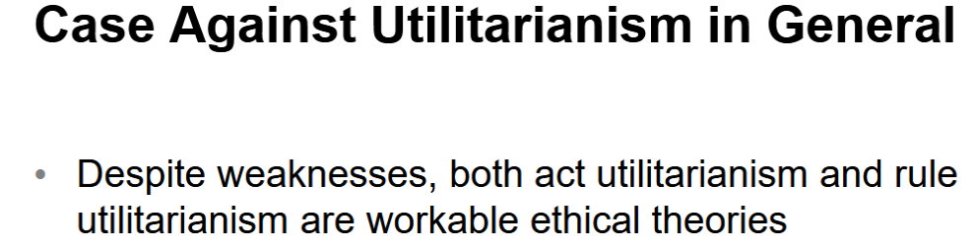
What is Social Contract Theory?
Social Contract Theory is the idea that people agree to follow certain rules to live peacefully in society. In return, the government enforces these rules to protect everyone.
Thomas Hobbes:
- Without rules, life would be lonely, dangerous, and short.
- People agree to follow rules (a social contract) to live peacefully.
- A government is needed to enforce these rules.
Jean-Jacques Rousseau:
- In a fair society, no one is above the rules.
- This prevents unfair or harmful rules from being made.

James Rachels’s Definition
Morality is a set of rules that people agree to follow so that everyone benefits— but only if others follow them too.
Kinds of Rights
Negative Right:
- A right that others respect by not interfering with you.
- Example: Freedom of speech—others just need to let you speak without stopping you.
Positive Right:
- A right that requires others to take action to help you.
- Example: Right to education—the government must provide schools and teachers.
Absolute Right
An absolute right is a right that applies without any exceptions (no matter what the circumstances are) —it must always be protected.
- Example: The right to life is often considered absolute because no one should take another person’s life, no matter the situation.
- Most negative rights, like freedom from torture, are usually seen as absolute because they require others to simply not interfere.

Limited right
A limited right is a right that can have restrictions depending on the situation.
Example:
- The right to education in the U.S.
- The government provides free schooling up to 12th grade.
- But for college, people usually have to pay because the government has a limited budget.
This means the right exists, but it’s not unlimited—it has some conditions.
Correlation Between Types of Rights
Positive rights (like free education or healthcare) require resources and government action, so they are more limited because resources are not unlimited.
- Example: A country may provide free education up to high school but not for college.
Negative rights (like freedom of speech or the right to life) usually just require others not to interfere, so they tend to be more absolute (without exceptions).
- Example: Your right to free speech exists as long as no one stops you from speaking.

John Rawls’s Theory of Justice
Every person should have basic rights and freedoms (like free speech, safety, and property ownership), but only if everyone else can have the same rights too. No one should have special privileges that take away others' rights.
Any social and economic inequalities must
- Be associated with positions that everyone has a fair and equal opportunity to achieve
- Be to the greatest benefit of the least-advantaged members of society (the difference principle)
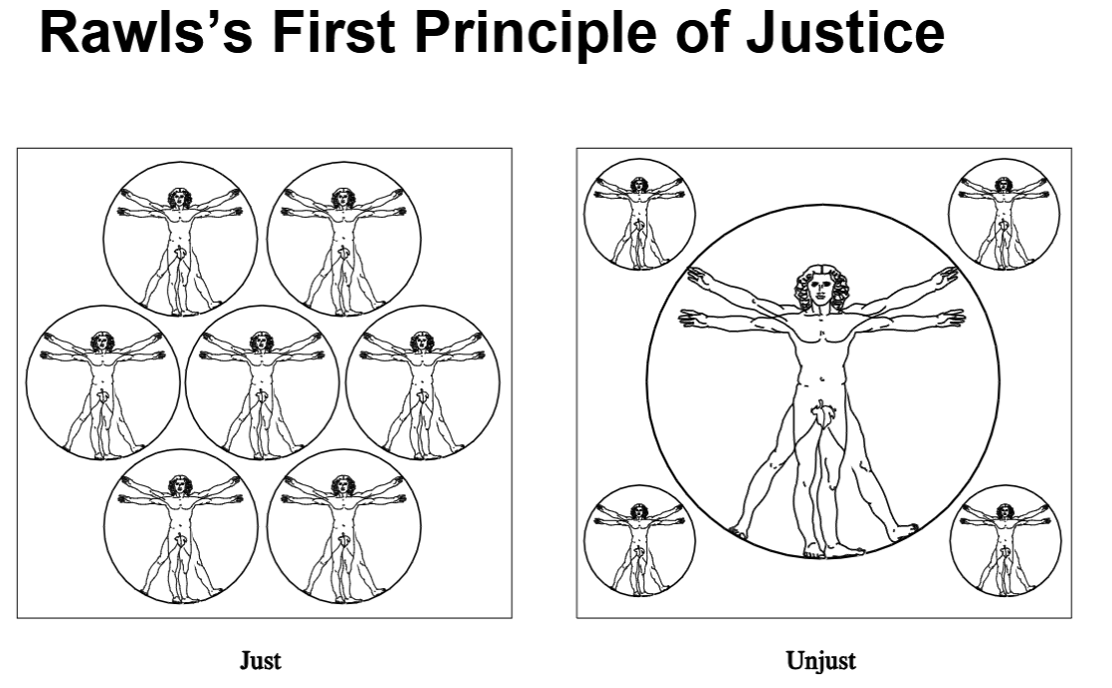
John Rawls’s the difference principle
- Suppose both of these income tax structures will produce the same income to the government. Plan A is a flat tax in which every citizen pays the same percentage of his or her income; plan B is a progressive tax in which the income tax rate gradually rises as a citizen’s income increases.
- Plan B does not treat every citizen equally, but the inequality is justified under Rawls’s difference principle because it is of greatest benefit to the most disadvantaged.
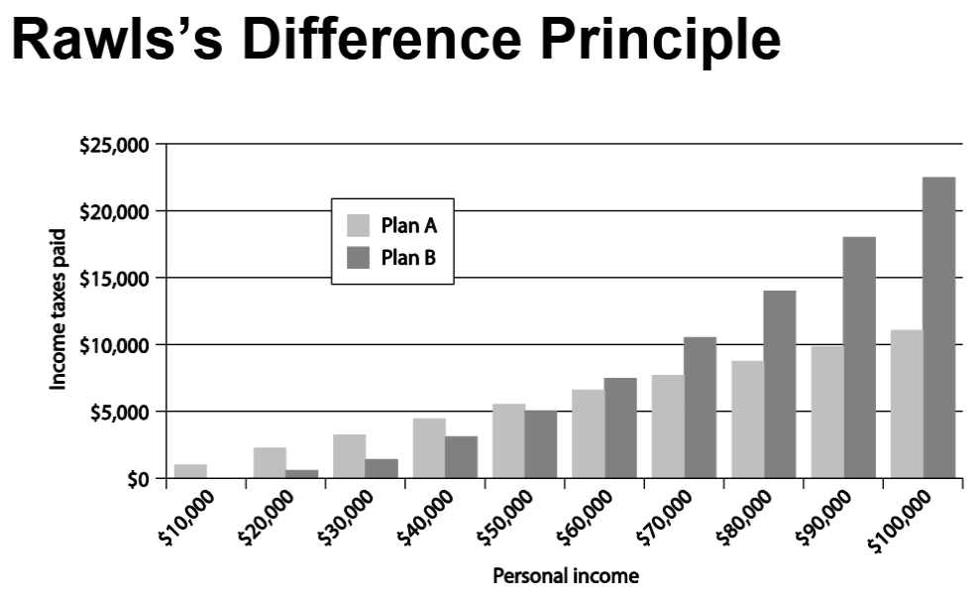DVD Rental Scenario
- Bill owns chain of DVD rental stores
- Uses a computer to keep track of the
- DVDs rented by each customer.
- Constructs profiles of customers
- Sells profiles to direct marketing firms
- Some customers happy to receive more mail order catalogs; others unhappy at increase in “junk mail”
Evaluation (Social Contract Theory)
- Consider rights of Bill, customers, and mail order companies.
- Does customer have right to expect name, address to be kept confidential?
- If customer rents DVD from bill, who owns information about transaction?
- If Bill and customer have equal rights to information, Bill did nothing wrong to sell information.
- If customers have right to expect name and address or transaction to be confidential without giving permission, then Bill was wrong to sell information without asking for permission.
Case for Social Contract Theory
- Based on Rights: It focuses on the rights people agree to have in society.
- Explains Self-Interest: Without agreed rules, people act only for themselves.
- Helps Understand Government Issues:
  - Punishing criminals is fair because they broke the rules everyone agreed to.
  - Following laws (civil obedience) is morally right because it keeps society stable.
- Practical Theory: It works well for real-world ethics and laws

Case Against SCT:
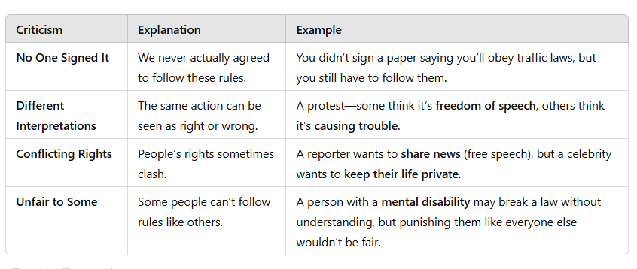
- Still workable Ethical Theory

Chapter 4
Intellectual Property
Intellectual Property?
Any unique product of the human intellect that has commercial value.
Examples:
- Books, songs, movies
- Paintings, drawings
- Inventions, chemical formulas, computer programs

Intellectual property ≠ physical manifestation: Intellectual property (ideas, inventions, creative works) is not the same as physical objects like a car or a house.
The question asks: Should the right to own physical property also apply to ideas, music, books, and inventions?
Yes, the right to own property can extend to intellectual property, but it works differently than owning physical things.
- Physical Property: If you own a car, only you can use it unless you give permission.
- Intellectual Property: If you create a book, song, or invention, others can copy it easily unless laws (like copyrights or patents) protect it.
So, intellectual property laws exist to give creators ownership rights, similar to physical property, but with different rules.
John Locke’s Property Rights
People have the right to:
- Own themselves – No one else owns your body or life.
- Own their work – If you work, the effort belongs to you.
- Own what they take from nature – If you gather resources (like picking apples or farming land), they become yours because of your labor.
But only if:
- You don’t take more than you need – No hoarding or wasting.
- You leave enough for others – Others should still have access to resources.

